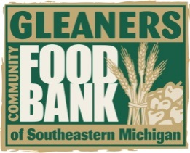
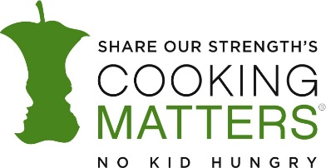
GLEANERS COMMUNITY FOOD BANK
Share our Strengths COOKING MATTERS AT THE STORE™
Satellite Partner End-of-Tour Reporting Form

Thank you for volunteering your time to host a Cooking Matters at the StoreTM Tour! Please complete a Tour Reporting Form for each tour you conduct.

Facilitator Information
Facilitator Name:Click or tap here to enter text.
Organization:Click or tap here to enter text.
Phone Number:Click or tap here to enter text.
Email Address:Click or tap here to enter text.
Are you willing to facilitate another tour? yes no

Tour Information
Type of Curriculum:Click or tap here to enter text.
Tour Date:Click or tap here to enter text.
Number of Facilitators:Click or tap here to enter text.
Number of Participants:Click or tap here to enter text.
Language in which tour was held:Click or tap here to enter text.
Did you complete the optional $10 challenge? yes no

Tour Location
Store Name:Click or tap here to enter text.
Store Street:Click or tap here to enter text.
Store City:Click or tap here to enter text.
Store State: Click or tap here to enter text. | Store Zipcode:Click or tap here to enter text.

Comments: Click or tap here to enter text.

RETURN THIS COMPLETED FORM AND PARTICIPANT SURVEYS TO cmsatellite@gcfb.org

Thank you for completing a Cooking Matters at the StoreTM Tour!
Cooking Matters at the StoreTM is generously supported by Walmart and the ConAgra Foods Foundation.

